Experiment 6: Vacuum Cleaner Problem
Aim
To solve the Vacuum Cleaner Problem using Python by cleaning all dirty rooms and reaching the goal state.

Algorithm (Short)
- Read the initial state of the rooms.
- Check whether the current room is dirty.
- If dirty, clean the room.
- Move to the next room.
- Repeat until all rooms are clean.
- Display the final clean state.

Python Code
rooms = ["Dirty", "Dirty"]

for i in range(len(rooms)):
if rooms[i] == "Dirty":
print("Cleaning Room", i + 1)
rooms[i] = "Clean"

print("Final State:", rooms)

Output
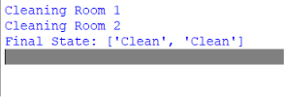
Result
The Vacuum Cleaner Problem was successfully solved using Python. All dirty rooms were cleaned, and the goal state was achieved.

